Appendix I: Handwriting Examples for Teleform

First, here are two examples of good handwriting for Teleform. The first set is pretty much “perfect” from a Teleform point of view. The second set is a bit messier but still acceptable. Key points are:
- Numbers do not touch any edges of the boxes or go outside the lines
- Numbers are not not written in an ambiguous way. (Examples of ambiguous numbers are given below.)

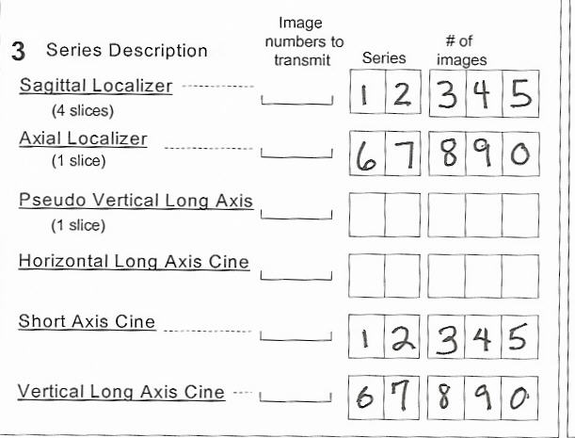

Now, here are some examples of writing that Teleform has trouble with:

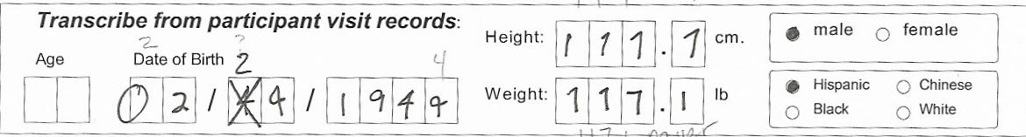

The Date of Birth was read as: 22 / ~4 /1944. Problems are:
- 0 goes outside the box
- 4 and 9 can be confused if not written carefully. If the horizontal “tail” on the number goes past the vertical line (as on the final digit of the year), Teleform will read it as a 4, even if the loop is rounded. Make sure that 9’s are not confused with 4’s.

Teleform read the Height as 111.7 and the Weight as 117.1, and did not ask for verification of either number.
- 1 and 7 can be confused if not written carefully. Write the numeral 1 as a straight line with no tail on top or bottome, like:

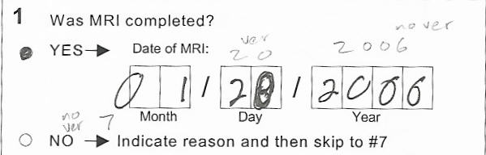

Teleform read this date as 71 / 20 / 2006, and the only numeral it was unsure of was the 0 in the “Day”. Problems are:
- 0 in month goes outside the box. Teleform reads only the part inside the box, which looks most like a 7.
- Second digit in Day has been written over. It is difficult to tell if it is intended to be a 0 or an 8. X- out mistakes and write the correction over the box. Do not write over mistakes as was done here.
- Last two 0’s in the Year look like 6’s, and the last 0 was read as a 6. Make sure that 0’s are closed at the top.

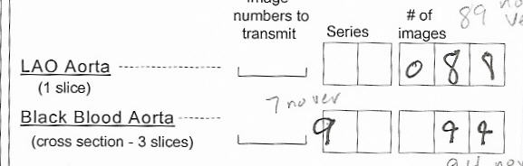

Teleform read the LAO Aorta number as 89, and the Black Blood Aorta numbers as 7 and 94. It did not bring any of the numbers up for verification. Problems are:
- Second digit in the number 88 does not have a loop in the bottom, so it looks like a 9.
- On the Black Blood line, again the first 9 is misread because it goes out of the box, and the last number is ambiguous because it is difficult to tell if the numbers are 4’s or 9’s.

Summary:
  - Make sure that numbers are completely inside the box
  - Form digits carefully so that there are no ambiguities. In particular, watch for problems with:
1 and 7
4 and 9
6 and 0
8 and 9
3. See below for optimal printing of letters and numbers:

A | B | C | D | E | F | G | H | I | J | K | L | M |  | 1 | 2 | 3 | 4 | 5 | 6 | 7 | 8 | 9 | 0
N | O | P | Q | R | S | T | U | V | W | X | Y | Z

